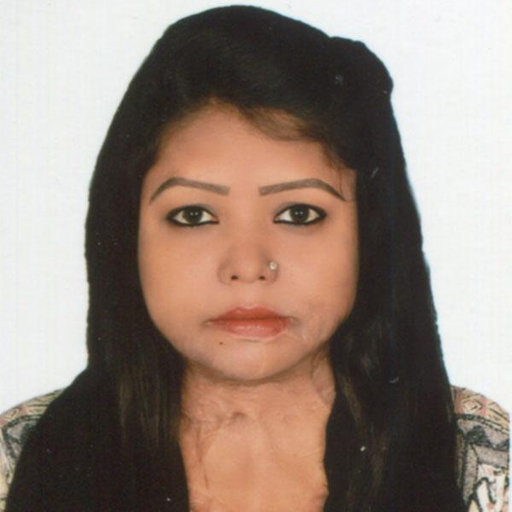  Contract Information: -  House # B2/B3, Road # 6, Alif Housing, Adabor Bazar  Mohammadpur, Dhaka-1207, Bangladesh  Contract me- 01333340256, 01719468238  Personal Email. Nizum143m@gmail.com  Official Email. Nusrat.nizum@bracu.ac.bd  SKILLS  Researchers, Dance teacher, School teacher, Social Educator  Computer Skills:  MS. Word. 80%  MS. Excel, 50%  MS. PowerPoint 50%  Email & Internet Browsing. 80%  ACHIEVEMENT  · Obtaining 1st Position from Class – 1to 8  · Won Multiple Dance Awards in District & Sub–sub-sub-district level competitions.  · Became Runner Up in the Selection Program of “Meghe Dhaka Tara”.  · Accompanied by Monira Rahman to collect “World's Children’s Prize” for Rights of the Child, Sweden, 2011.  · Kumarika missed the Natural 2016 Courageous Beauty Award.  TRAINING  •Computer Training,  o IGT, (December, 2013- August 2014)  o Cyber Tech (August 2011- February 2012) Result: A +  o RADIO JOCKEY (April 2014 - June 2014), Radio Today, 34 Bata, 19th floor, Banani, Dhaka.  •Peer Educator Training for ‘APON’ BRAC, Bogura.  •Life & Social Skills, Leadership, and Counseling Training in Acid Survivors Foundation  Follow me-  linkedin.com/in/mst-nusrat-jahan-nizum-76693b183  PERSONAL INFORMATION  Name: Mst. Nusrat Jahan  Nizum  Father's Name: Md. Afsar Ali  Mother's Name: Mst. Momotaj Begum  Permanent address:  Village: Sholartair Post Office: Kutubpur Police Station: Saria Kandis  District: Bogura  Present address:  House # B2/ B3, Road # 06 Alif housing Adabor Bazar  Dhaka-1207  Date of Birth: April 24, 1994  Religion: Islam (Sunni)  Blood Group: “O” positive  Marital Status: Single | MST. NUSRAT JAHAN NIZUM
 | ABOUT ME
 | I am an acid survivor. I am a young, Enthusiastic & hard-working person who is aiming to build a decent career and seeking a challenging opportunity where I will be able to utilize my strong organizational skills and educational background, and which will allow me to grow personally and professionally. I have been helping my family financially with a job. I am self-motivated and able to work both independently and as a collaborative team member. Hence, any Employer can be assured about my sincerity, punctuality, honesty, along with excellent performance.
 | WORK EXPERIENCE
1) BRAC James P Grant School of Public Health, BRAC University, March 2022
Sr. Research Assistant
Major Responsibilities:
- Contribute to developing the field plan
- Manage and monitor the data collection activities of enumerators and field researchers. Conducting thorough field visits.
- Manage enumerator recruitment and training processes, demonstrating strong organizational and interpersonal skills
- Prepare IOU requisition, Bill adjustment (Data Collector)
- Organize training sessions, including refreshers
- Supervise field-related activities (travel planning, ticket purchase, room booking, meeting with local stakeholders) for one study
- Submit at least one blog post every year
- Tool development -
a. Quantitative (assist in survey tool);
b. Qualitative (assist in developing interview guide);
- Data collection -
a. Quantitative (participate/supervise a survey),
b. Qualitative (participate in interview/observation/take field notes)
- Data analysis -
- Qualitative - transcribe/translate interviews, learn basics of coding, and assist in developing codebooks.

Project: 1. ARISE Bangladesh, 2. Access 4 All

2) Human Development Research Centre June 2021- July 2021
Field Officer
Project: Vvoices from the margins and inclusive policies Response to the COVID-19 Epidemic Project
Major Responsibilities:
Ø Interview with the family members
Ø Data Collection on Surveyor System in Tab
Ø Collective data on cities and marginal populations of different tribes on the COVID-19 epidemic.
Ø Organize and facilitate focus group discussions (FGDs)
Ø Frequently conduct field visits and household visits to the beneficiaries
Ø Provide supervision to the data collection team in respective geographical areas and ensure that data collection proceeds smoothly and on time.
4) Acid Survivors Foundation April 2019 - June 2020
Young Woman Leader
Responsibilities:
- Risk management and case management.
- Research, Data Collection, Tools Development, Data Processing, Analysis, and Database Management.
- Advocacy & Networking, Communication, Coordination, and Stakeholder Management.
- Make an action plan depending on the program of project.
- Project Operation & Monitoring.
- Youth Leadership Buildup.
- Project Activity & Program Implementation.
- Prepare Field Visit Report.
- To develop a case story, lessons learned, and Challenges.
5) Acid Survivors Foundation (UNDP) January 2019 - March 2019
Research Assistant
Responsibilities:
- Included building relationships with acid survivors to collect their life stories
- Data survey
- Report writing and share research outcomes
- Research: Data Collection, Tools Development, Data Processing, Analysis, and Database Management.
- Prepare field report.
- Develop case stories, lessons learned, and Challenges.

6) Voluntary Service Overseas (VSO) January 2018 - March 2018
National Youth Volunteer
Project: National Citizen Service (NCS) Project
Major Responsibilities:
Ø Conduct a participatory survey and contribute to the planning of the project
Ø Work in human rights & gender equity, Youth Development, gender awareness to project stakeholders, and UP representative that reflects on community mobilization.
Ø Support conducting project design, project planning, marketing, linkages with local government Institutions, Service providers, Govt departments, and private sectors, ensuring governance through reproductive health, livelihood interventions, development of production groups, and organizing the event and Community Action Day.
Ø Community-Based Child Protection, Promote Child-Friendly Governance at the Union level.
Ø Liaison and networking, communication between leading discussions and meetings, oral and written communication both in Bengali and English.
Ø Formation of women and adolescent groups focused on the poor and marginalized.
Ø Assist in developing an environmental drama, Foxing, and other community awareness.
Ø Stop Child Marriage for community mobilization, advocacy, and courtyard Meetings.
Ø Support the set-up of the adolescent group/ leader with the community mobilizer; To prepare an Activities Report on the project.

6) BRAC March 2006- December 2013
“Kishori Netri”- Peer Educator
Project: Adolescent Development Program
Responsibilities:
•Conducting a Class in BRAC School, Specializing in “Apon”- Syllabus.
• Physical Trainer
• Dance Teacher
• Moderator of the Book Exchange program.
• Conduct Campaigns on:
o Child Marriage, Dowry, Family Planning, HIV
o Eve teasing, Gender Discrimination, Rape
o Acid Violence, Sexual Assault, Violence against Women
7) Light House
Peer Educator
Duties Responsibilities:
v Counseling Survivors.
v Home Visit.
v Conduct School Campaign.
v Holding Meetings:
§ Union Council.
§ District Council.
§ DC office.
v Arranging Conferences.
 | EDUCATION
Government Titumir College Session: 2017- 2018
M.B.A. Final Marketing
Faculty: Marketing
Obtained: CGPA: 3.17 Passing Year: December 2021

Government Titumir College Session: 2013- 2014
B.B.A. An Honors (Bachelor's in Marketing)
Faculty: Marketing
Obtained: CGPA: 2.97 Passing Year: August 2019

Publication:-
Rashid, S., Alam, W., Hossain, R., Ara, Y., Oishy, T., & Nizum, M. N. (2024). Displaced Lives and Social Networks: Lived Experiences of Climate Migrants in Bangladesh. Health Education & Behavior [ Manuscript submitted for publication].

Nizum, N. J. (2023) শহরের নিন্ম আয়ের ঘনবসতিপূর্ন এলাকায় বসবাসকারী কিশোরী মেয়েদের মধ্যে মাসিক নিয়ে কুসংষ্কার ও ভ্রান্ত ধারনাঃ প্রয়োজন খোলামেলা আলোচনার (Superstitions and misconceptions about menstruation among adolescent girls living in densely populated, low-income urban areas: Need for open conversations). (2023). Bracjpgsph.org.
https://bracjpgsph.org/assets/pdf/Advocacy/communication%20tools/blog/23.01.11_Blog_Nusrat_Draft%203.pdf
 | REFERENCE
- Sabina Faiz Rashid, PhD
Professor, Mushtaque Chowdhury Chair in Health and Poverty
(Endowed by the BRAC Founder, Late Sir F.H. Abed)
Director, Center of Excellence for Gender, Sexual and Reproductive Health and Rights (CGSRHR)
BRAC James P Grant School of Public Health, BRAC University
01713117767
sabinafrashid@gmail.com

Bachera Aktar
Deputy Director, The Center of Excellence for Gender, Sexual and Reproductive Health and
Rights (CGSRHR)
BRAC James P Grant School of Public Health, BRAC University
01729070662
bachera.aktar@bracu.ac.bd
Certify that all information stated in this resume is authentic and complete to the best of your knowledge.

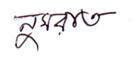
Mst. Nusrat Jahan Nizum.

