Curriculum Vitae of Saira Parveen Jolly
Contact  Saira Parveen Jolly  PhD Candidate  Department of Health Sciences  University Medical Center Groningen, University of Groningen  The Netherlands  E: sairaparveenjolly@gmail.com ; saira.jolly@bracu.ac.bd  M: +8801769913427 | 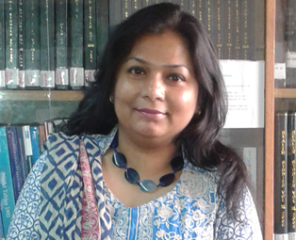
Summary of Professional Experience
I have experience in public health nutrition and nutritional epidemiology with expertise in clinical and community-based trials focused on maternal, neonatal and child health and nutrition. Currently, I work at BRAC James P Grant School of Public Health, BRAC University, Bangladesh, and am pursuing a PhD at the University Medical Center Groningen, The Netherlands.

Work experience
- Assistant Scientist, BRAC James P Grant School of Public Health, BRAC University, Bangladesh (2019-Present)
- Research Fellow, BRAC Research and Evaluation Division, (2011- 2019)
- Scientific Officer, Bangladesh Council of Scientific and Industrial Research, Bangladesh (2006-2011)
- Research Assistant, International Center for Diarrhoeal Disease, Bangladesh (2004-2006)

Educational Qualification
- PhD, University Medical Center Groningen, University of Groningen, The Netherlands (on going)
- M.Sc. in Nutrition and Health, Wageningen University and Research (WUR), the Netherlands, 2010
- M.Sc. in Nutrition, University of Dhaka, Bangladesh, 2003
- B.Sc. in Food and Nutrition, University of Dhaka, Bangladesh, 2001

Skills
- Experienced in research design, protocol development, tool creation, monitoring and supervision, data analysis, report writing, results dissemination, and organizing workshops, seminars, and conferences

Recent Publications
Jolly SP, Roy Chowdhury T, Sarker TT, Afsana K. Water, sanitation and hygiene (WASH) practices and deworming improve nutritional status and anemia of unmarried adolescent girls in rural Bangladesh. J Health Popul Nutr. 2023 Nov 13;42(1):127. doi: 10.1186/s41043-023-00453-8.

References
Dr S K Roy, Chairperson, Bangladesh Breastfeeding Foundation, Dhaka, Bangladesh
E: skroy1950@gmail.com
M: +8801943220587

